Machine Learning Lab
Lab Report – Lab 4
Name | Rakshitaa Harnal
Section-Batch | A-A1
Roll No. | 05
Subject | Machine Learning Lab

Lab No. | Lab 4
Lab Title | Decision Tree Classification (Entropy criterion) for Wine Quality Prediction
Aim | To build a Decision Tree classifier using the entropy criterion to predict the quality of red wine from its physicochemical properties, and to evaluate it using accuracy, precision, recall, F1-score and a confusion matrix.
Objectives | 1. Load and inspect the Red Wine Quality dataset. 2. Perform univariate, bivariate and multivariate EDA. 3. Detect outliers using the IQR method. 4. Split data into train/test sets using stratified sampling. 5. Train a Decision Tree (entropy) and evaluate it. 6. Visualise the tree and analyse overfitting.
Dataset / Resources | winequality-red.csv: 1599 records, 11 numeric input features and the target "quality" (scores 3 to 8). Python, Jupyter Notebook, pandas, NumPy, matplotlib, seaborn, scikit-learn.
Date of Performance | __ / __ / 2026

1. Theory

1.1 Decision Tree Classifier
A Decision Tree is a supervised learning algorithm that classifies data by asking a sequence of questions about the input features. Each internal node tests a feature against a threshold (for example alcohol ≤ 10.53), each branch is the outcome of the test, and each leaf node holds a class label. The tree is built top-down by choosing, at every node, the split that best separates the classes. It is easy to interpret and needs no feature scaling, but it can overfit when grown very deep.

1.2 Entropy and Information Gain
Entropy measures the impurity (disorder) of a node: Entropy = − Σ pi log2(pi), where pi is the proportion of samples of class i in the node. A pure node has entropy 0, while a node with evenly mixed classes has high entropy. Information Gain is the reduction in entropy after a split: IG = Entropy(parent) − Σ (nk/n) × Entropy(child k). With criterion = "entropy", the tree picks the split with the highest information gain at each node. The alternative criterion is Gini impurity, 1 − Σ pi².

1.3 Overfitting and Pruning
If a tree is allowed to grow until every training sample is classified correctly, it memorises noise and performs poorly on unseen data. This is overfitting, seen as very high training accuracy but much lower test accuracy. It can be controlled by pre-pruning (max_depth, min_samples_split, min_samples_leaf) or post-pruning (cost-complexity pruning, ccp_alpha).

1.4 Evaluation Metrics
Accuracy is the fraction of correct predictions. Precision = TP/(TP+FP) shows how many predicted positives are correct; Recall = TP/(TP+FN) shows how many actual positives are found; F1-score is their harmonic mean. For multi-class problems these are averaged (macro or weighted). A confusion matrix tabulates actual versus predicted classes, with correct predictions on the diagonal.

1.5 Other Techniques Used
Stratified train-test split keeps the class proportions the same in the training and test sets, which is important for an imbalanced target. The IQR method flags values below Q1 − 1.5×IQR or above Q3 + 1.5×IQR as outliers. Exploratory Data Analysis (EDA) uses histograms, box plots, scatter plots, a correlation heatmap and pair plots to understand the data before modelling.

2. Code (GitHub)
The complete notebook for this lab has been uploaded to GitHub:
GitHub URL: https://github.com/<your-username>/<repository-name>
Key code used in the experiment:
df = pd.read_csv("winequality-red.csv")
df.isnull().sum(); df.duplicated().sum()

# IQR outlier detection for every feature
features = df.drop(columns=["quality"])
Q1 = features.quantile(0.25); Q3 = features.quantile(0.75); IQR = Q3 - Q1
lower = Q1 - 1.5*IQR; upper = Q3 + 1.5*IQR
outlier_count = ((features < lower) | (features > upper)).sum()

# Quality groups for analysis
df["quality_group"] = pd.cut(df["quality"], bins=[0,5,6,10], labels=["Low","Medium","High"])

X = df.drop(columns=["quality","quality_group"]); y = df["quality"]
X_train, X_test, y_train, y_test = train_test_split(X, y, test_size=0.20, random_state=42, stratify=y)

dt_model = DecisionTreeClassifier(criterion="entropy", random_state=42)
dt_model.fit(X_train, y_train)
y_test_pred = dt_model.predict(X_test)

accuracy_score(y_test, y_test_pred); classification_report(y_test, y_test_pred)
confusion_matrix(y_test, y_test_pred)
plot_tree(dt_model, feature_names=X.columns, filled=True, rounded=True, max_depth=3)

3. Procedure and Materials Used

Materials
- Hardware: Laptop/PC with Python 3 environment
- Software: Jupyter Notebook; Python libraries pandas, NumPy, matplotlib, seaborn and scikit-learn
- Dataset: winequality-red.csv with 1599 samples. Features: fixed acidity, volatile acidity, citric acid, residual sugar, chlorides, free sulfur dioxide, total sulfur dioxide, density, pH, sulphates, alcohol. Target: quality

Procedure
- Import the libraries and load the dataset using pd.read_csv().
- Inspect the data with head(), tail(), columns, info(), describe() and shape; check null values (none) and duplicate rows (240).
- Perform univariate analysis: histograms with KDE for every column, box plots for alcohol and quality, and a count plot of quality.
- Perform bivariate analysis: box plots of each feature against quality and scatter plots of alcohol and volatile acidity against quality.
- Detect outliers in every feature with the IQR method and plot the outlier counts.
- Perform multivariate analysis: correlation heatmap, pair plot, and quality groups (Low, Medium, High).
- Separate features X (11 columns) from the target y (quality) and perform an 80:20 stratified train-test split (random_state = 42).
- Train DecisionTreeClassifier(criterion="entropy", random_state=42) on the training set.
- Predict on the training and test sets and compute accuracy, precision, recall, F1-score and the classification report.
- Plot the confusion matrix and visualise the decision tree (full tree and top 3 levels).

4. Output Screenshots and Descriptions
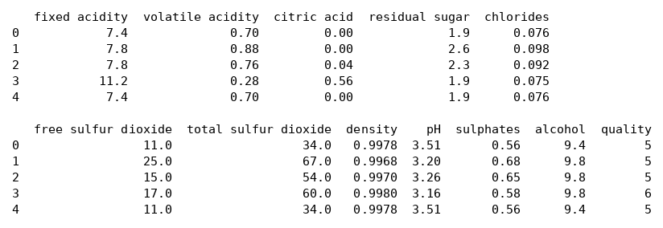
Output 1: First five records of the dataset (df.head())
The head() output shows the first five rows of the red wine dataset. Each row is one wine sample described by eleven physicochemical measurements such as fixed acidity, volatile acidity, citric acid, residual sugar, chlorides, sulfur dioxide levels, density, pH, sulphates and alcohol. The last column, quality, is the sensory score given to the wine, here 5 or 6. All features are numeric and on very different scales, for example density is near 1 while total sulfur dioxide is in the tens. Rows 0 and 4 have identical values, which hints at duplicate records.
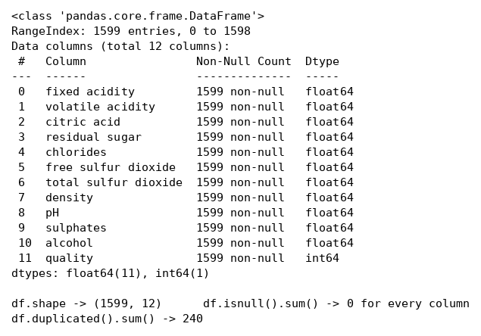
Output 2: Dataset information, shape, null values and duplicates
The info() output confirms the dataset has 1599 entries and 12 columns, with 11 float64 features and one int64 target (quality). Every column has 1599 non-null values and isnull().sum() returns 0 for all columns, so no missing-value treatment is needed. The shape is (1599, 12). However, duplicated().sum() reports 240 duplicate rows. In the notebook drop_duplicates() was called without saving the result, so the duplicates remain in the data used for modelling.
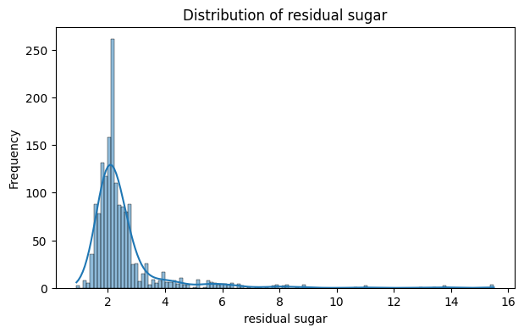
Output 3: Histogram with KDE of residual sugar
The histogram of residual sugar is strongly right-skewed. Most wines have residual sugar between about 1.5 and 3 g/L, with a sharp peak near 2, while a long tail extends to about 15.5 g/L. The KDE curve follows this narrow peak and long tail. Such skewness means this feature has many extreme values, which agrees with the outlier count found later (155 outliers). Decision trees are not affected much by skewed features because they split on thresholds, not on distances.
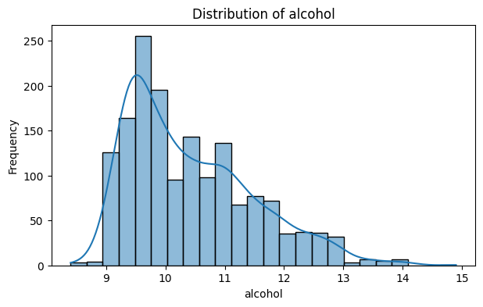
Output 4: Histogram with KDE of alcohol
Alcohol content is moderately right-skewed, with most wines between 9 and 11 percent and the highest peak near 9.5 percent. The frequency steadily falls towards 14 percent, with only a few wines above 13.5 percent. The KDE curve shows a main peak and a small secondary bump near 11 percent. Alcohol is an important feature in this lab, as it is later used for the very first split of the decision tree.
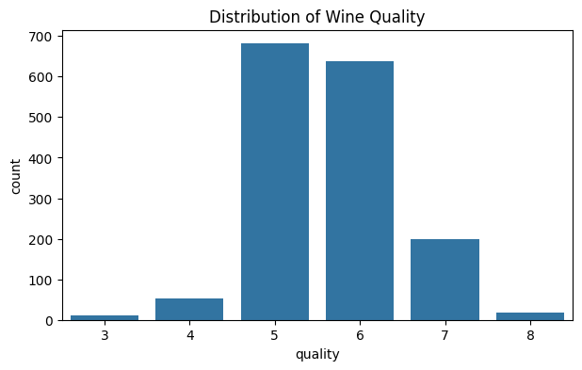
Output 5: Distribution of wine quality (count plot)
The count plot shows that wine quality is concentrated in the middle scores. Quality 5 has 681 samples and quality 6 has 638, while quality 7 has 199, quality 4 has 53, quality 8 has 18 and quality 3 has only 10. The target is therefore imbalanced, with about 83 percent of wines rated 5, 6 or 7 and very few at the extremes. This is why a stratified split was used, and it also explains why the model predicts rare classes poorly.
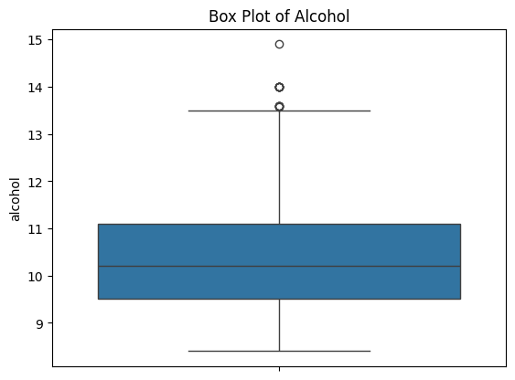
Output 6: Box plot of alcohol
The box plot of alcohol shows a median of about 10.2 percent, with the box (middle 50 percent of wines) between roughly 9.5 and 11.1 percent. The upper whisker ends near 13.5 percent, and a few points above it, including one near 14.9 percent, are plotted as outliers. There are no outliers on the lower side. This matches the IQR table, where alcohol has only 13 outliers (0.81 percent), the second smallest count among all features.
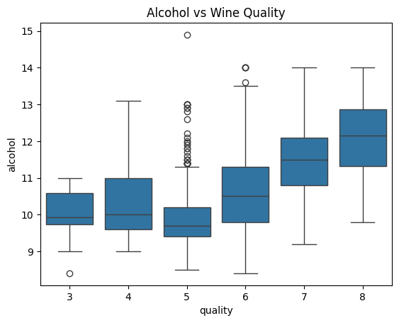
Output 7: Alcohol vs wine quality (box plot)
This bivariate box plot compares the alcohol content across quality scores 3 to 8. In general, the median alcohol rises with quality, from about 10 percent for low scores to about 12 percent for quality 8. Quality 5 wines have the lowest median alcohol and show many high outliers, whereas quality 7 and 8 wines have clearly higher alcohol. This shows that alcohol is positively related to quality and is a strong predictor, which agrees with its correlation of 0.48 in the heatmap.
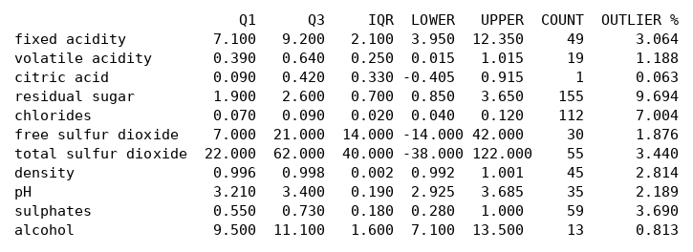
Output 8: IQR outlier summary for all features
This table lists Q1, Q3, IQR, the lower and upper bounds, and the number of outliers for each of the 11 features. Residual sugar has the most outliers (155, 9.69 percent), followed by chlorides (112, 7.00 percent), sulphates (59) and total sulfur dioxide (55). Citric acid has just one outlier and alcohol has 13. Since wine measurements can legitimately vary, the outliers were only analysed and not removed from the data.
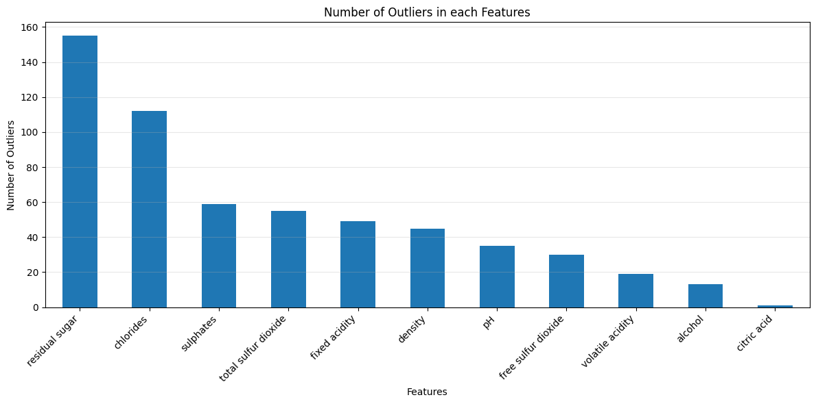
Output 9: Number of outliers in each feature (bar chart)
The bar chart presents the outlier counts from the previous table in descending order. Residual sugar and chlorides stand far above the other features, while citric acid and alcohol have the fewest outliers. The chart makes it easy to see which features need the most attention if scaling or outlier treatment is required. Decision trees are fairly robust to outliers because splits depend on the order of values and not on their magnitude.
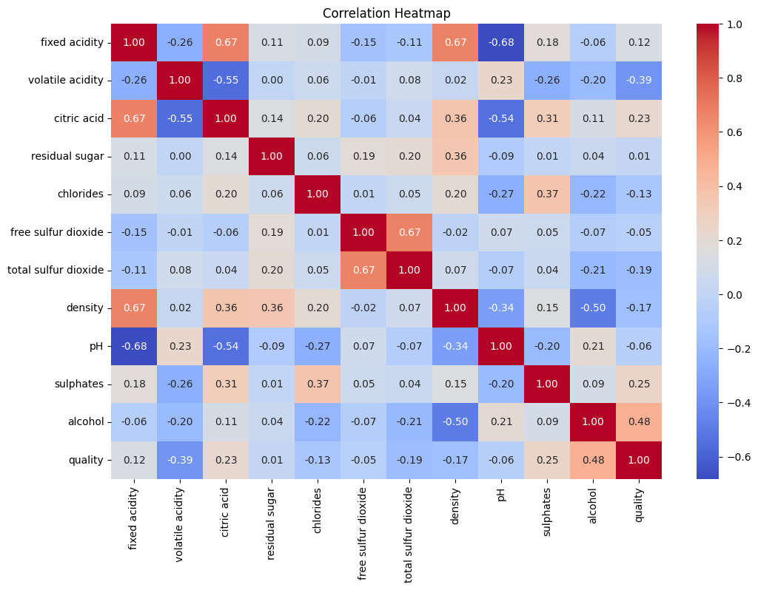
Output 10: Correlation heatmap
The heatmap shows pairwise correlations among all variables. Alcohol has the strongest positive correlation with quality (0.48), followed by sulphates (0.25) and citric acid (0.23), while volatile acidity has the strongest negative correlation (−0.39). Residual sugar (0.01) and free sulfur dioxide (−0.05) have almost no relationship with quality. Among the features themselves, fixed acidity is strongly related to citric acid (0.67), density (0.67) and pH (−0.68). These findings explain which features the tree prefers to split on.
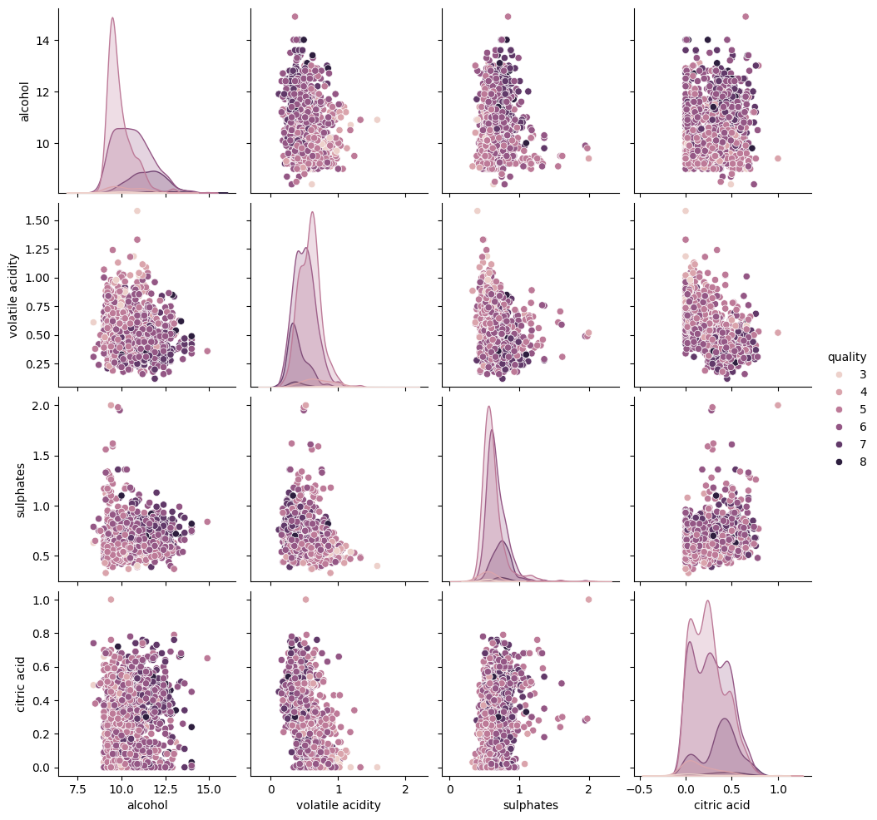
Output 11: Pair plot of alcohol, volatile acidity, sulphates, citric acid and quality
The pair plot shows scatter plots and distributions for five selected variables, with points coloured by quality. The diagonal shows the distribution of each variable for every quality class. The plots reveal that higher-quality wines tend to have higher alcohol and sulphates and lower volatile acidity. The quality classes overlap heavily in all the scatter plots, so no single pair of features separates them cleanly. This overlap suggests that predicting exact quality will be difficult for any model.
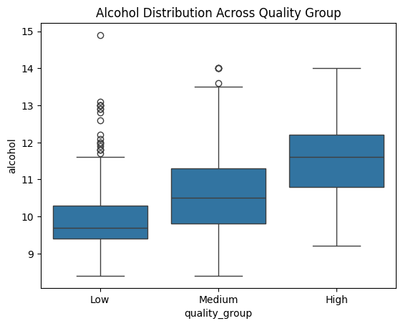
Output 12: Alcohol across quality groups (Low, Medium, High)
Wine quality was grouped into Low (3–5), Medium (6) and High (7–8). The box plot shows the median alcohol increasing across the groups, from about 9.7 percent for Low to about 10.5 percent for Medium and about 11.6 percent for High. The Low group also has many high-alcohol outliers. This confirms the trend seen earlier and shows that grouping the target makes the relationship with alcohol easier to see. The groups were used only for analysis, not for training.
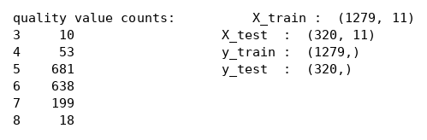
Output 13: Class counts and train-test split shapes
The value counts show the class distribution of the target: 681 wines of quality 5, 638 of quality 6, 199 of quality 7, 53 of quality 4, 18 of quality 8 and 10 of quality 3. The features X contain 11 columns after the quality and quality_group columns are removed. An 80:20 stratified split gives 1279 training samples and 320 test samples. Stratification keeps the class proportions the same in both sets, so even the rare classes appear in the test data.
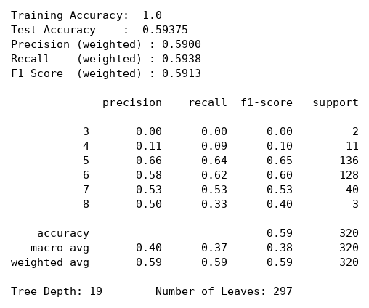
Output 14: Decision tree performance metrics and classification report
The entropy-based decision tree reaches a training accuracy of 1.00 but a test accuracy of only 0.594, which is a clear sign of overfitting. The weighted precision, recall and F1-score are about 0.59. The classes 5 and 6, which have the most samples, get F1-scores of 0.65 and 0.60, while class 3 gets 0.00 and class 4 gets 0.10 because they have very few samples. The macro F1-score (0.38) is much lower than the weighted score. The fully grown tree has a depth of 19 and 297 leaves.
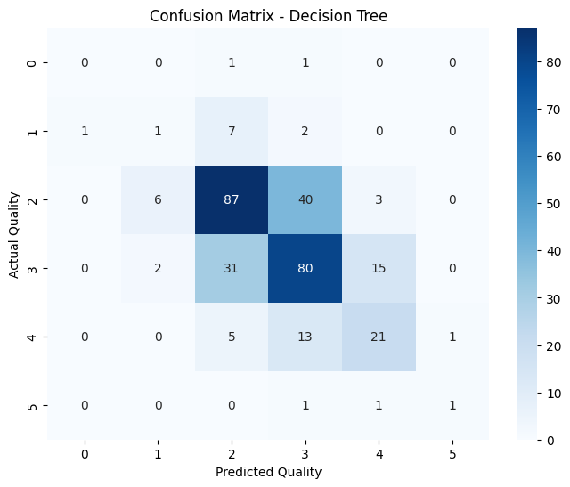
Output 15: Confusion matrix of the decision tree
The confusion matrix compares actual and predicted quality on the 320 test samples. Axis labels 0 to 5 stand for quality classes 3 to 8. The strongest cells are on the diagonal: 87 correct predictions for quality 5, 80 for quality 6 and 21 for quality 7. Most mistakes are between neighbouring classes, for example 40 quality-5 wines predicted as 6 and 31 quality-6 wines predicted as 5. The rare classes 3 and 4 are almost never predicted correctly.
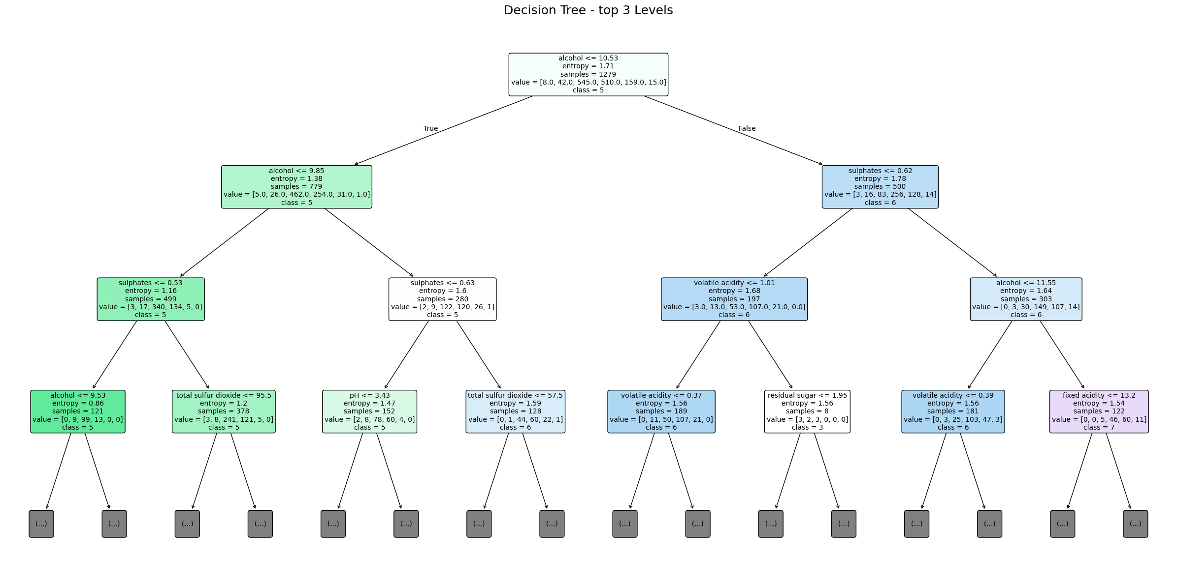
Output 16: Decision tree (top 3 levels)
This figure shows the first three levels of the entropy-based tree built on 1279 training samples. The root splits on alcohol ≤ 10.53 with an entropy of 1.71, which shows alcohol gives the highest information gain. The left branch (lower alcohol) mostly predicts quality 5 and then splits on alcohol and sulphates, while the right branch (higher alcohol) predicts quality 6 or 7 and uses sulphates and volatile acidity. Node colours show the majority class, and deeper levels are hidden as (...) for clarity.

Result Summary
Metric | Train | Test
Accuracy | 1.000 | 0.594
Precision (weighted) | – | 0.590
Recall (weighted) | – | 0.594
F1-score (weighted) | – | 0.591

Conclusion: The entropy-based decision tree (depth 19, 297 leaves) memorised the training data but achieved only about 59 percent accuracy on unseen wines. Alcohol, sulphates and volatile acidity were the most useful features. Performance is weakest for rare quality classes because of class imbalance. Limiting the tree depth (pre-pruning), cost-complexity pruning, class weighting, or using an ensemble such as Random Forest should improve generalisation.

5. Viva Questions with Solutions
Q1. What is entropy and how does a decision tree use information gain?
Ans: Entropy measures the impurity of a node, Entropy = − Σ pi log2(pi); it is 0 for a pure node. Information gain is the drop in entropy after a split. With criterion="entropy", the tree chooses at every node the feature and threshold with the highest information gain. In this lab the root split was alcohol ≤ 10.53.
Q2. Why does the model show 100% training accuracy but only 59.4% test accuracy?
Ans: The tree was grown without any depth limit (depth 19, 297 leaves), so it memorised the training samples including noise. This is overfitting: very low bias but high variance, so it does not generalise well to new data.
Q3. How can overfitting in a decision tree be reduced?
Ans: By pre-pruning with max_depth, min_samples_split, min_samples_leaf or max_leaf_nodes, by post-pruning using cost-complexity pruning (ccp_alpha), by tuning these values with cross-validation, or by using ensemble methods such as Random Forest.
Q4. Why was stratify=y used in train_test_split?
Ans: The target is imbalanced (for example only 10 wines of quality 3 and 18 of quality 8). Stratified splitting keeps the same class proportions in the training and test sets, so rare classes are present in both and evaluation is more reliable.
Q5. Why are precision, recall and F1-score used along with accuracy?
Ans: Accuracy can hide poor performance on minority classes. Precision and recall show the errors per class, and F1 combines them. Here the weighted F1 is 0.59 but the macro F1 is only 0.38, showing that rare classes are predicted badly. The confusion matrix shows exactly which classes get confused.

